Docker Task
Task Description:
Install docker on EC2 and explore the docker commands (docker images, containers, volumes, network)
==================================================================
Steps - Creating EC2: -
- Logged into AWS Account -> EC2 -> Click Launch Instance => To Create New EC2 instance (Instance Name is DockerVM).
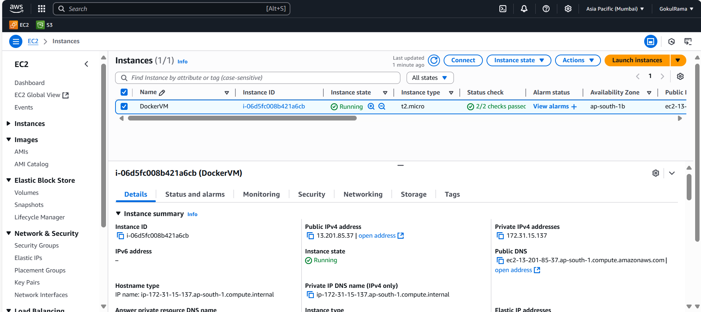

- Once created the new instance (DockerVM) -> Click Connect

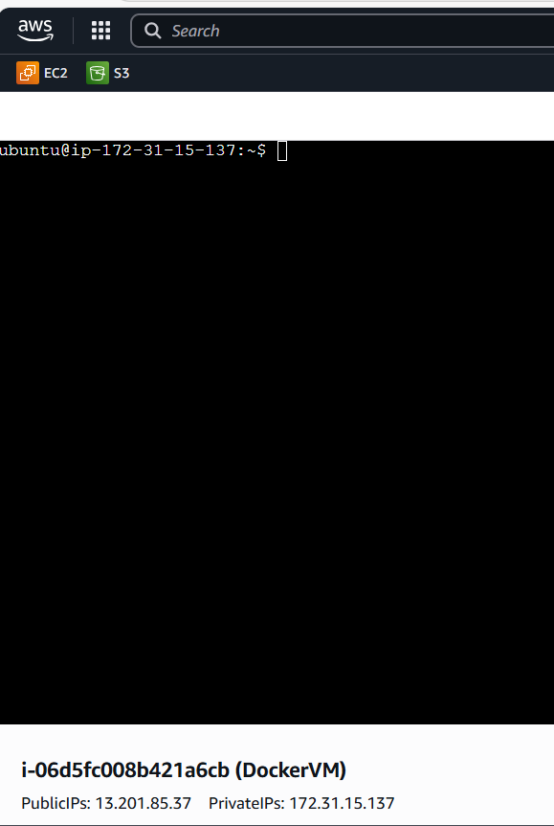

Steps – Install Docker: -
- Below command is to update all the required packages in the Linux machine from libraries for the VM that you created.
- Command is sudo apt-get update
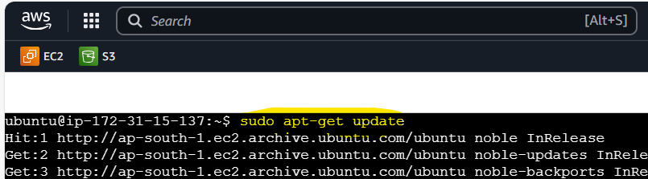
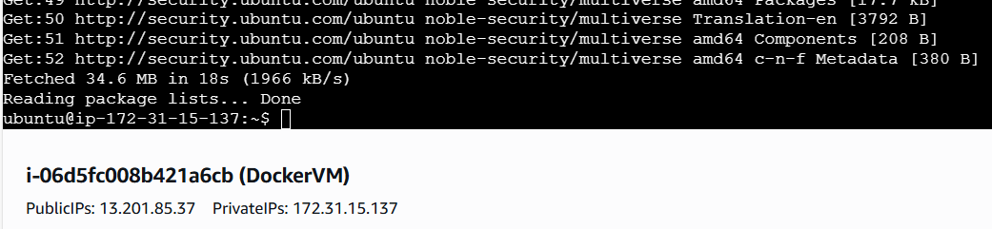

- Below command is used to install the docker in VM.
- Command is sudo apt install docker.io -y
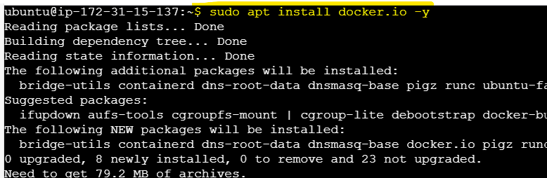
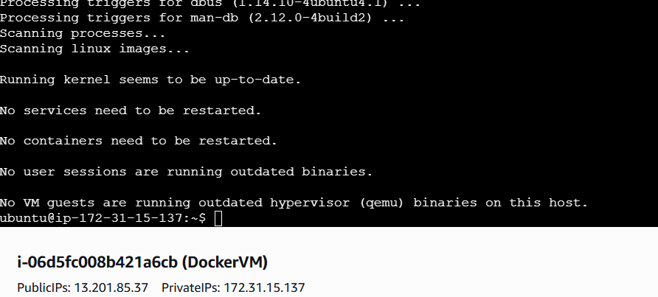

- Once docker has been installed successfully then need to check the docker version.
- Command is used to check the docker version
docker --version
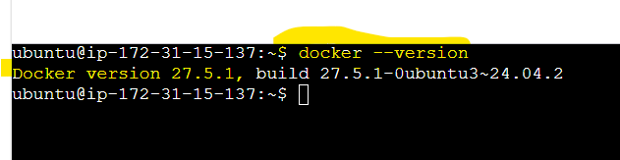

- Below command is to verify the docker status: -
- Command is sudo systemctl status docker
- If the status is active then the respective service is running.
- If the status is inactive then the respective service is not running.
- Below command is used to start the inactive docker service
sudo docker service start
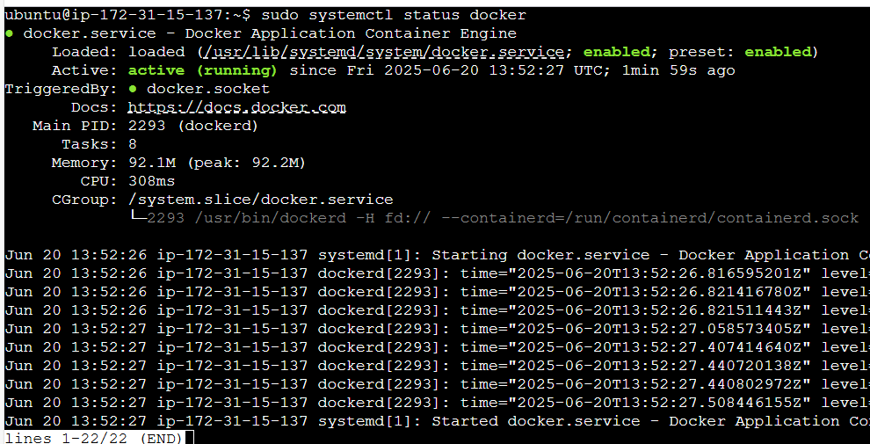

Explore the docker commands (docker images, containers, volumes, network): -
- To get Docker Images: -
- Below command is used to pull the docker images from docker hub to local VM is,
sudo docker pull <image name>
sudo docker pull nginx
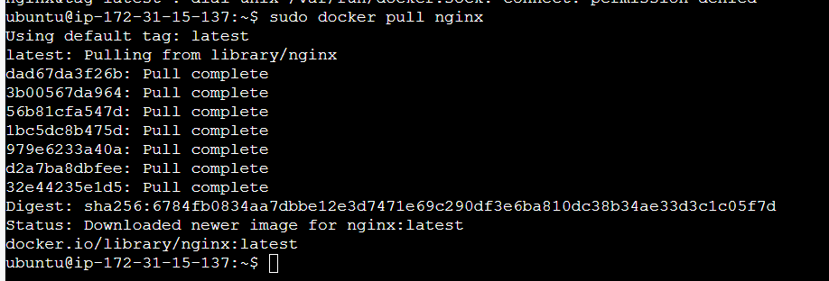
To view the list of all available docker images in local VM: -
- Below command is used to view all the available images in EC2 instance,
Command is sudo docker images
Here,
nginx is the image name that we downloaded from docker hub to local EC2 instance (VM) using the above docker pull command.
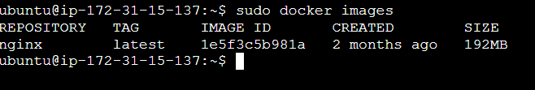

- To Create Docker Containers: -
- Below highlighted command is used to create container and respective docker image.
Command is sudo docker run -itd -p “9090:80” nginx (It create container and download nginx image automatically from docker hub)
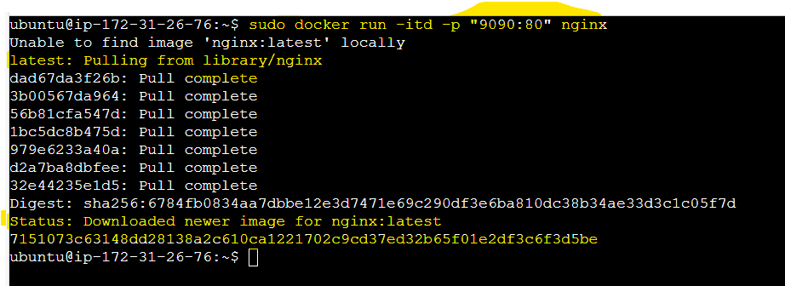

- Below highlighted command is used to view the list of downloaded images in local machine (EC2 instance).
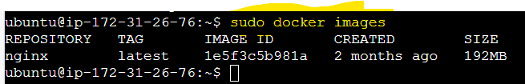

- Below highlighted command is used to view all the available containers in EC2.
Command is sudo docker ps -a

- Add the custom TCP Port (9090) in EC2 inbound rule. Reason is the incoming traffic reaches EC2 via port 9090
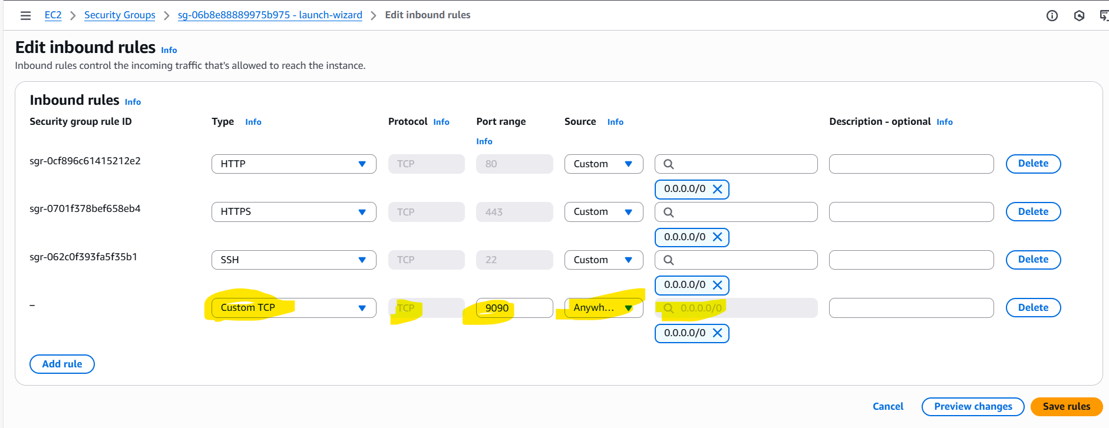

- If you spin the container inside EC2 -> Hit the EC2 Public IP with respective port (9090) then you get the respective docker (nginx) image.
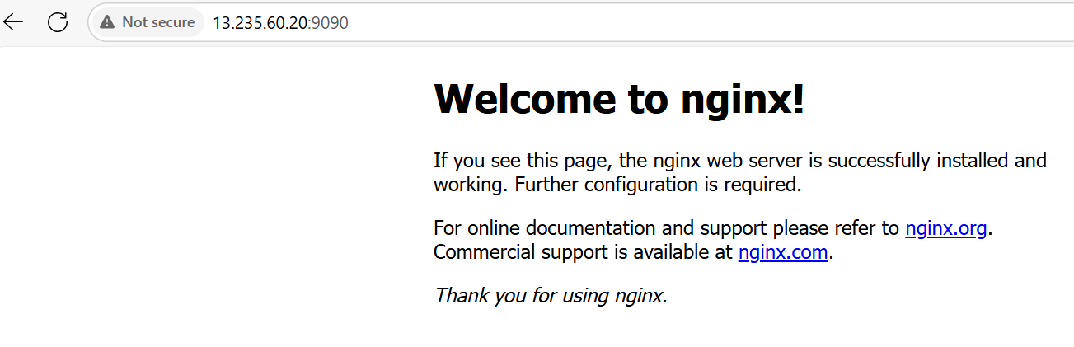

- Using Single docker image (nginx) we can spin the multiple containers:-
    - Command is sudo docker run -itd -p “9091:80” nginx

Note: -
sudo docker run -itd -p “9090:80” nginx -> Throwing an error.
Reason is 9090 port already used above (Error message is Port already used).
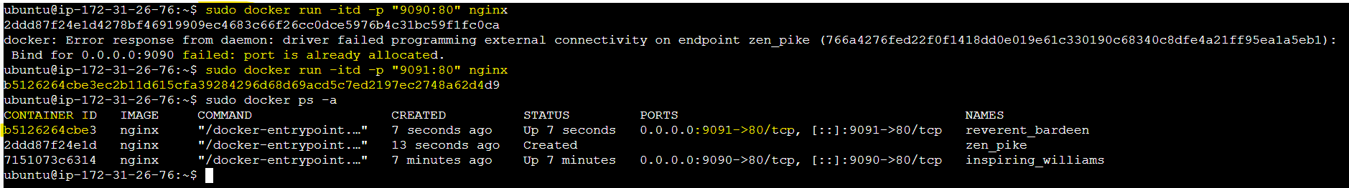

    - Add Custom TCP port (9091) in EC2 inbound rule
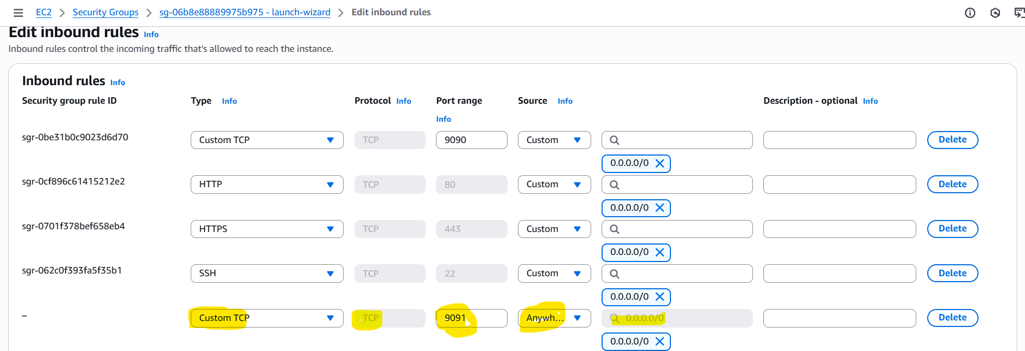

    - If you spin the multiple containers inside EC2 -> Hit the EC2 Public IP in both ports [9091 & 9090] then you get the respective docker (nginx) image.

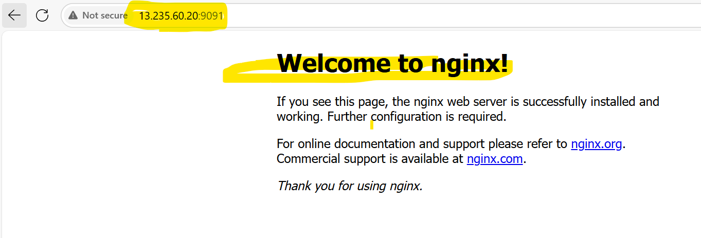

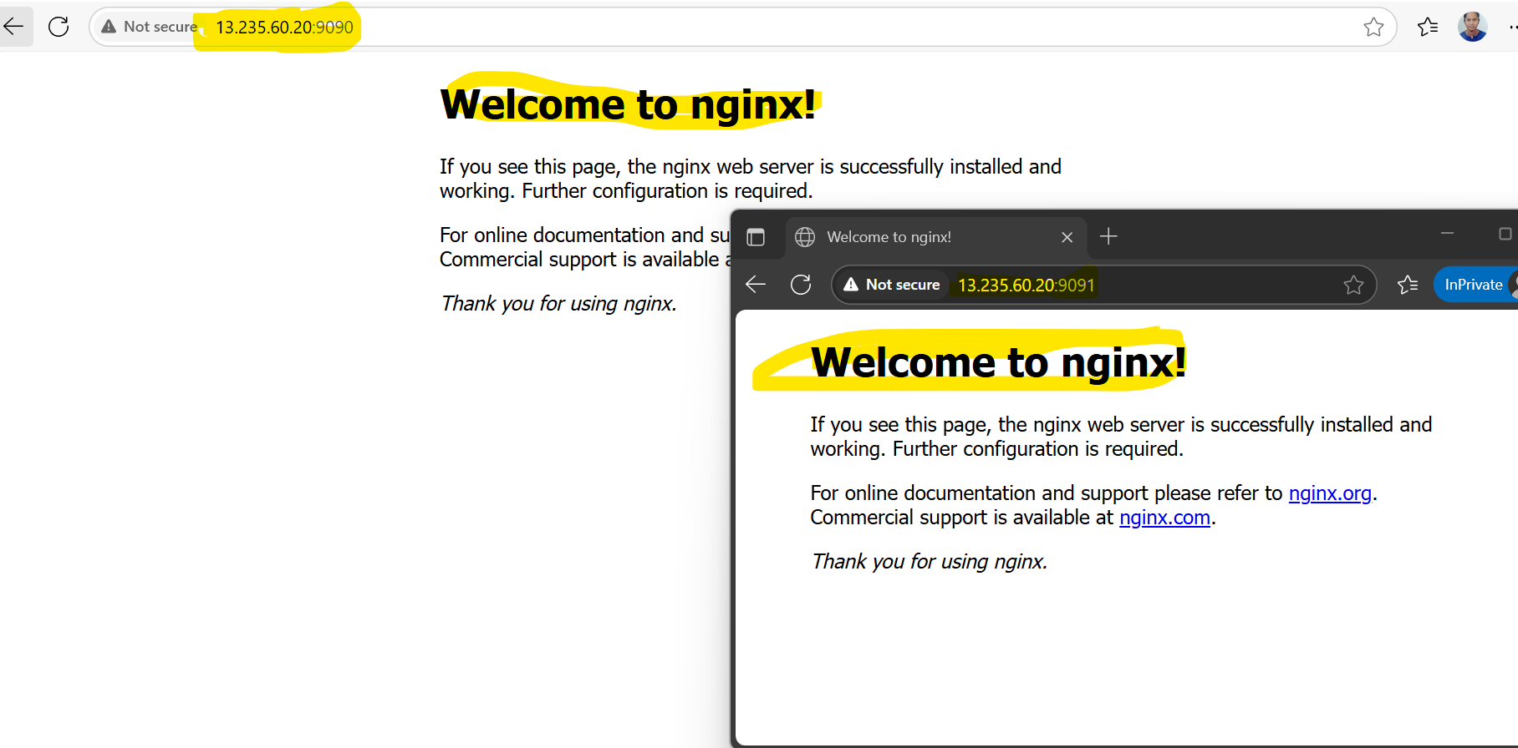

- Using both different docker image we can run multiple containers: -
  - Below highlighted command is used to create container with different port (9093) and different docker image (httpd)
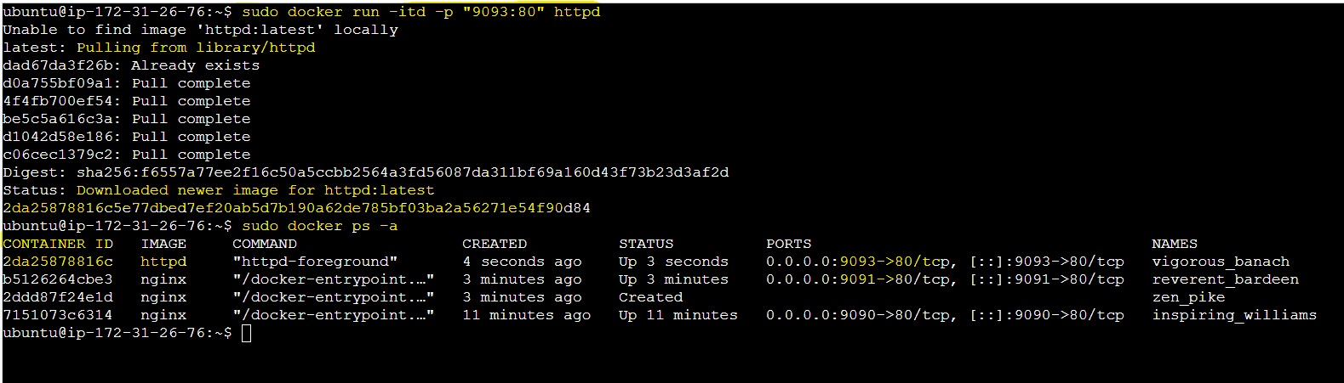

  - Add the respective port in EC2 inbound security rule.

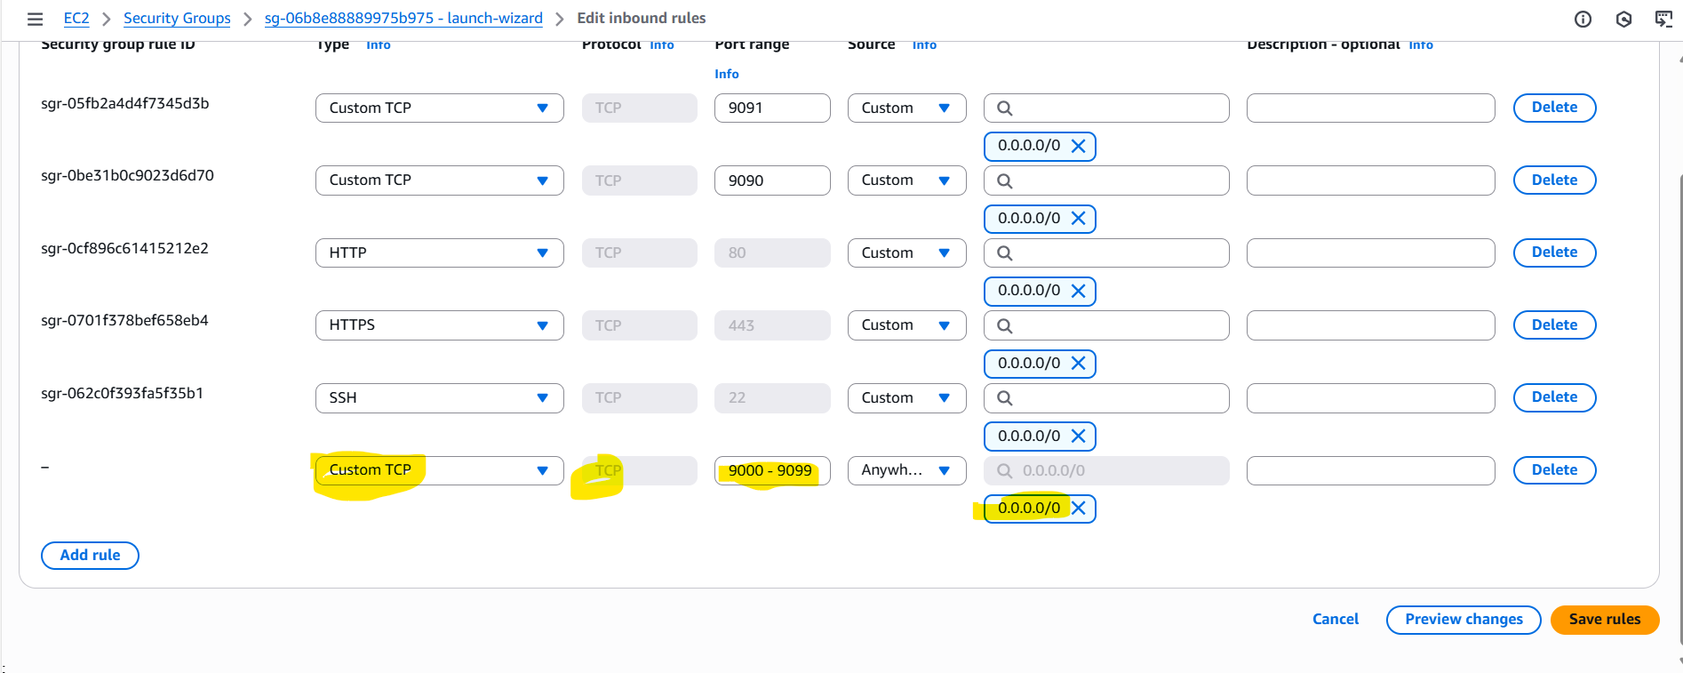

  - If you spin the multiple containers inside EC2 -> Hit the EC2 Public IP in both ports [9090, 9091 & 9093] then you get the respective docker (nginx and httpd) image.

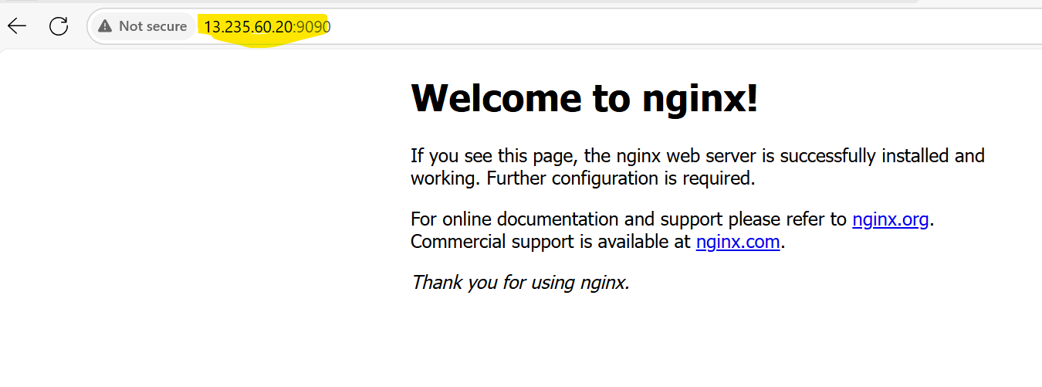

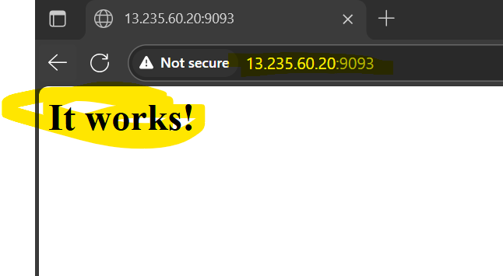

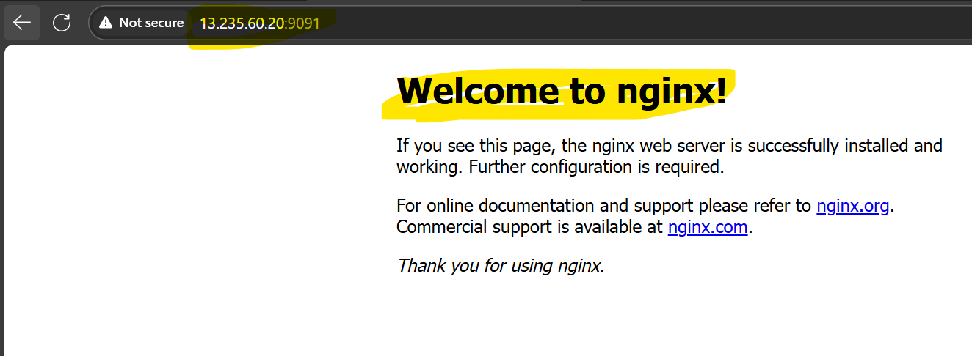

- To Create Docker Network: -
  - Create EC2 instance: -
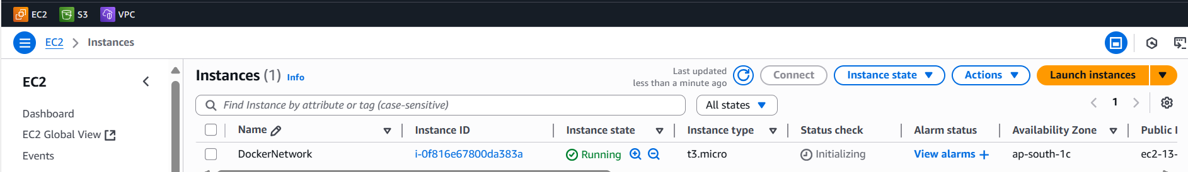

  - Install Docker: -

- This command is to update latest package

- This command is to install docker in EC2

- Command to check the docker version.
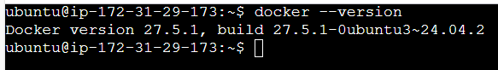

- Below command is used to list available images in EC
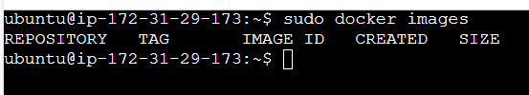

  - Creating Bridge Networking: -
- Highlighted first command is used to create bridge networking.
- Once the bridge has been created check what are the available networks available in EC2. Using this below highlighted second command
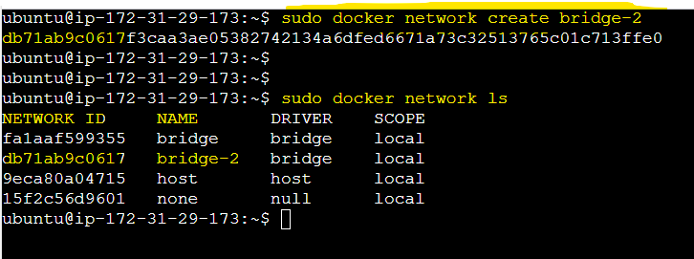

- Create and run the docker container and download the nginx image using bridge network by using the below highlighted command
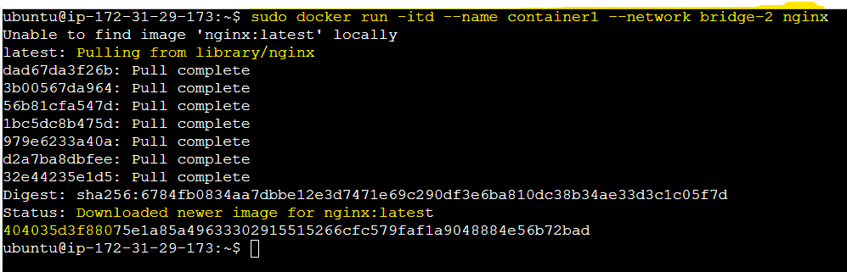

- List the available images in EC2
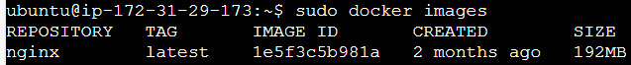
- List all the running containers by using the below command

- Execute the docker container and getting ping command is not available, so will install ping utility from libraries
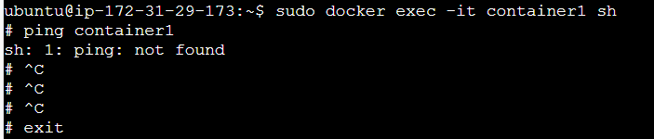

- Installing ping utilities
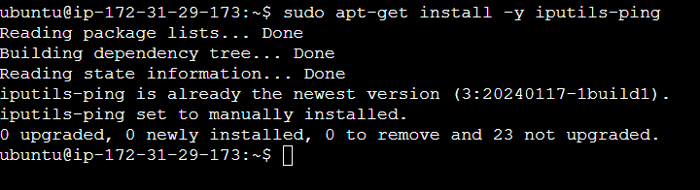

- Execute the docker container, getting the positive response
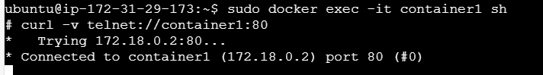

- To Create Docker Volume: -
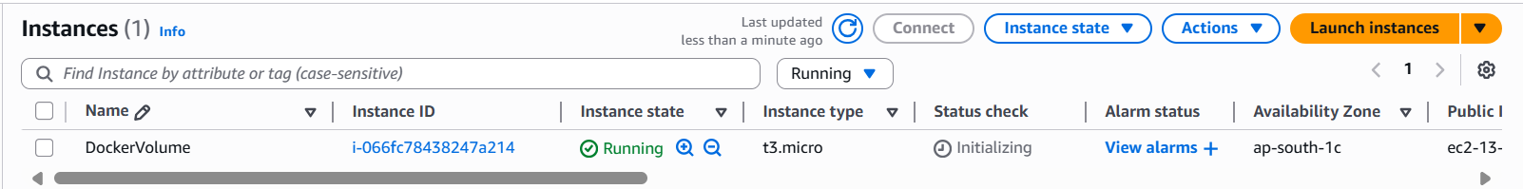

  - Install Docker: -

- This command is to update latest package

- This command is to install docker in EC2

- Command to check the docker version.
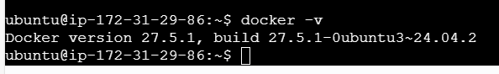

- Below command is to list all available volumes in EC2
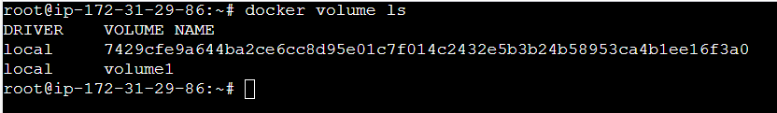

- Below command is to create new volume (Volume Name is volume2)

- Below command is to check created volume are properly created or not by
using list volume command

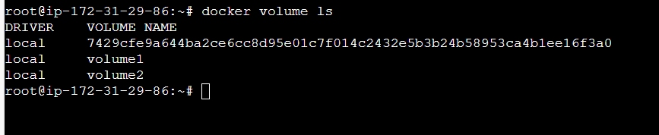

- Below command is to check the details of volume
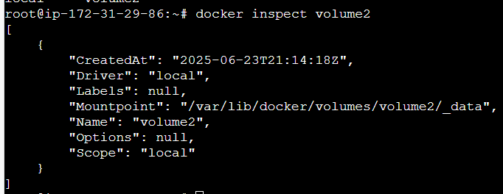

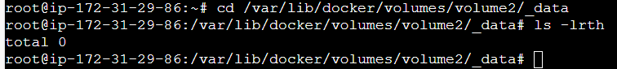

- Create one sample file in my local folder and copied into another folder inside newly created volume
